

**TechnoHacks EduTech**

A

Internship Report

on

“Data Analytics Internship”

BY

Dinesh Kumar Manimela

At

TechnoHacks EduTech

**Internship Completion Certificate**

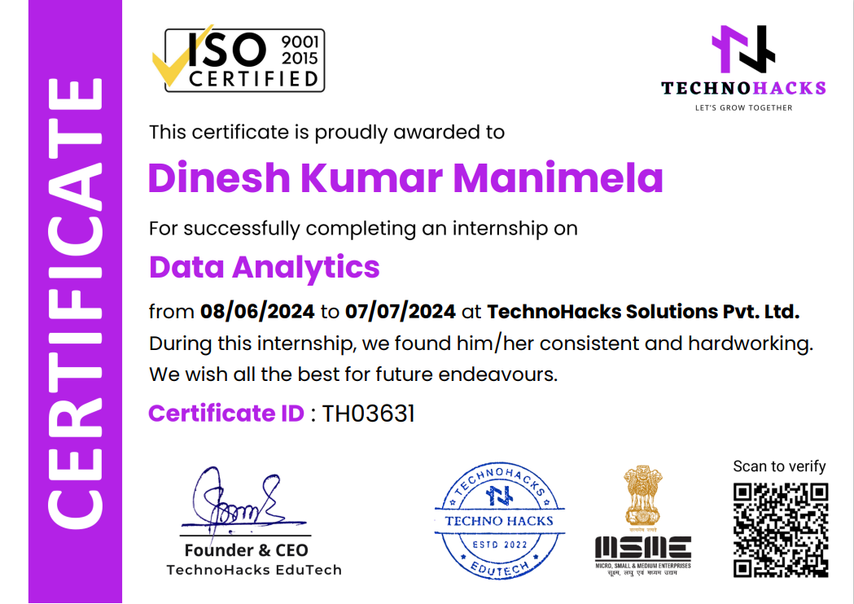

**Acknowledgement**

The internship opportunity I had with TechnoHacks EduTech was a great chance for learning. I am also grateful for having a chance to meet so many wonderful people and professionals who led me through this internship period. In light of the foregoing, I'd like to take this opportunity to express my heartfelt gratitude, with a special thanks to Mr. Sandip Gavit, Founder & CEO of TechnoHacks EduTech, took time out to hear, guide, and keep me on the correct path, allowing me to carry out my tasks at their esteemed organisation and extending their support during the training and internship.

I express my deepest gratitude to the honourable principal, Ramana Reddy Sir of Vikas Group of Institutions, for providing an opportunity to attend and complete an internship at TechnoHacks EduTech. I express my profound sense of gratitude to Suresh Betham, Head of the Department of Computer Science and Engineering, for giving me this opportunity and for her/his guidance. I avail myself of this opportunity to express my sincere gratitude to my whole department for their guidance and valuable suggestions.

I am extremely great full to my department staff members and friends who helped me in successful completion of this internship. I will continue to work on improvement, in order to attain desired career objectives.

**Intern Name:** Dinesh Kumar Manimela

**Company Background**

TechnoHacks EduTech is a cutting-edge software development company based in Nashik, Maharashtra. Established in 2022, our company has quickly gained recognition for our innovative solutions and commitment to excellence in the field of technology with a team of 10-50 dedicated professionals, we specialize in providing a wide range of services including web development, application development, corporate training, and digital marketing solutions.

Our mission is to empower businesses of all sizes by leveraging the latest technologies to enhance their online presence and streamline their operations. At TechnoHacks EduTech, we take pride in our ability to deliver customized solutions that meet the unique needs and objectives of each client. Whether it's creating a dynamic website, developing a user-friendly mobile app, or implementing a comprehensive digital marketing strategy, our team is dedicated to delivering results that exceed expectations.

As a company, we are driven by our core values of integrity, excellence, and collaboration. We believe in building strong, long-lasting relationships with our clients and partners, and we are committed to exceeding their expectations every step of the way.

At TechnoHacks EduTech, we are passionate about technology and dedicated to helping businesses thrive in the digital age. We look forward to the opportunity to work with you and help you achieve your goals.

**Website**: www.technoahacks.co.in

**Industry**: IT services & Corporate Training

**Company size**: 10-50

**Headquarter**: Nashik, Maharashtra

**Abstract**

This report presents an in-depth analysis of a Data Analytics project aimed at extracting actionable insights from large datasets. The project's primary objectives included identifying trends, patterns, and correlations within the data to facilitate informed decision-making.

The report details the project's methodology, which involved data collection, cleaning, and preprocessing to ensure data quality and reliability. Various statistical and machine learning techniques were employed for data analysis, including regression analysis, clustering algorithms, and data visualization techniques.

The outcomes of the project were evaluated based on the accuracy of predictions, the identification of key factors influencing outcomes, and the effectiveness of data-driven recommendations. The report also discusses the implications of the findings on business strategies and potential areas for further research and improvement.

Overall, the Data Analytics project demonstrated the value of data-driven approaches in uncovering valuable insights and driving informed decision-making processes.

**Top of Form**

**Introduction**

This introduction sets the stage for a Data Analytics internship program, focusing on providing practical knowledge and expertise to participants. The internship aimed to bridge the gap between theoretical concepts and real-world applications in data analytics, emphasizing core areas such as data analysis, statistical modeling, and programming.

Interns were actively involved in hands-on experiences, working on data analytics projects under the guidance of experienced professionals. The introduction outlines the program's objectives, curriculum structure, teaching methodologies, and the technologies utilized throughout the internship period.

Assessment of the program's effectiveness involved evaluating interns' proficiency levels in data analytics before and after the internship, showcasing improvements in coding skills, problem-solving capabilities, and collaborative teamwork. Insights and feedback from mentors and interns provide valuable perspectives on the program's strengths and areas for potential enhancement.

**Objectives**

Internships are often hailed as a valuable experience for college students looking to gain practical insights into a particular field. However, individuals from various backgrounds can also derive immense benefits from data Analytics internships, enriching their skills and knowledge in this dynamic and evolving domain.

Demonstrate proficiency in core data analytics concepts: Show a strong interest in gaining practical experience to improve data analytics skills and exhibit a deep understanding of essential concepts in data analytics.

• Highlight diverse applications of data analytics: Illustrate the wide range of data analytics applications across industries like healthcare, finance, marketing, and supply chain management, emphasizing its relevance in various professional domains.

• Explore diverse opportunities in data analytics internships: Recognize the broad scope of responsibilities within data analytics internships, including tasks such as data cleaning, trend analysis, predictive modeling, and data visualization, aimed at providing a comprehensive grasp of data analytics tasks and complexities.

• Emphasize the career benefits of data analytics internships: Emphasize the importance of data analytics internships in enhancing one's CV and acquiring advanced data analytics skills that can give individuals a competitive advantage in the job market.

• Encourage showcasing specialized data analytics skills: Encourage candidates to showcase any specialized data analytics skills, such as expertise in data mining techniques or experience in business intelligence tools like Tableau, to distinguish themselves and enhance their prospects of securing a data analytics internship.

**Results and tasks performed**

**Project Title:** Perform Data Cleaning

* **Topic:** Cleaned a dataset by removing missing values and outliers
* **Technologies Used:** Excel
* **Team Members Name (Individual):** Dinesh Kumar
* **Screenshot of Result and Code:**

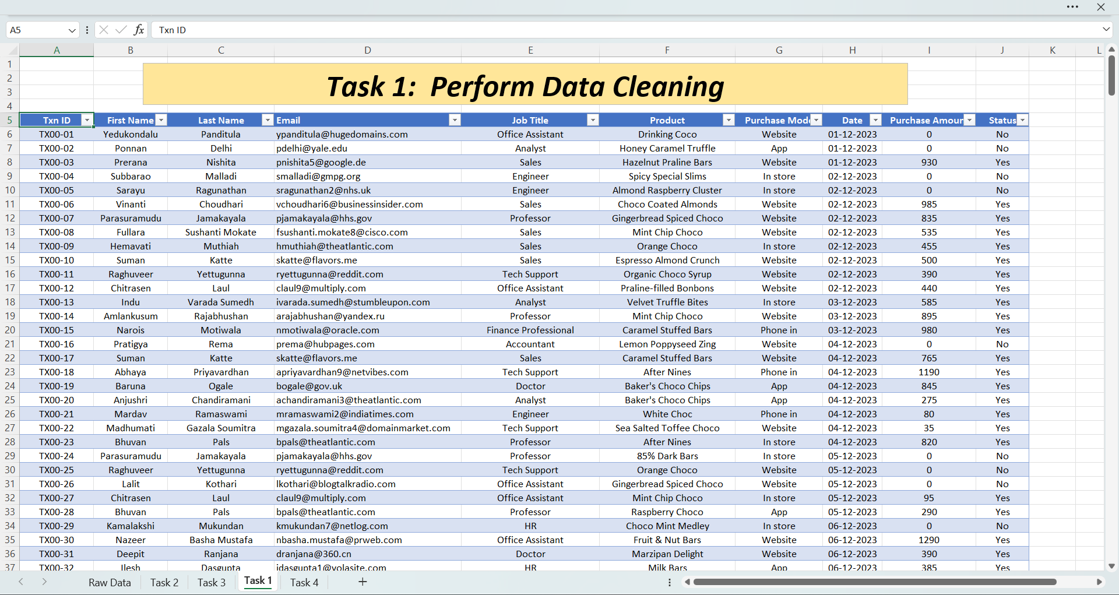

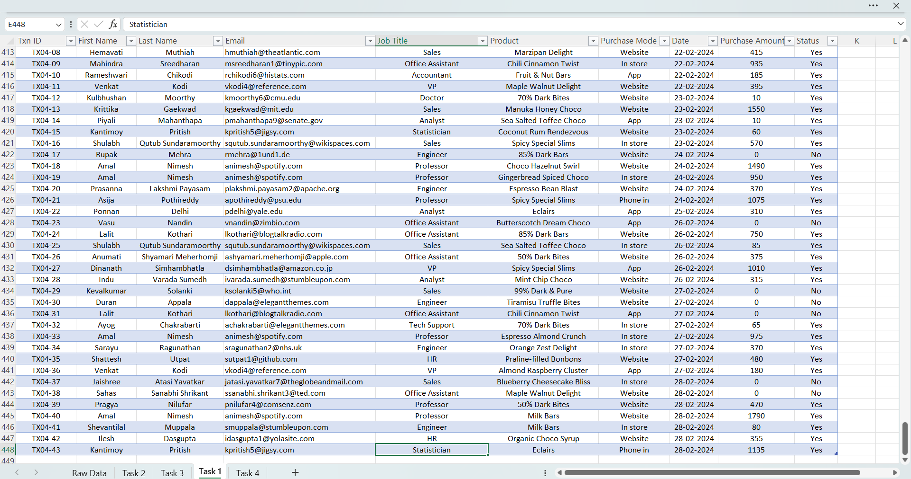

**Project Title:** Calculate Summary Statistics

* **Topic:** Calculated summary statistics (mean, median, mode, standard deviation) for a dataset
* **Technologies Used:** Excel
* **Team Members Name (Individual):** Dinesh Kumar
* **Screenshot of Result and Code:**

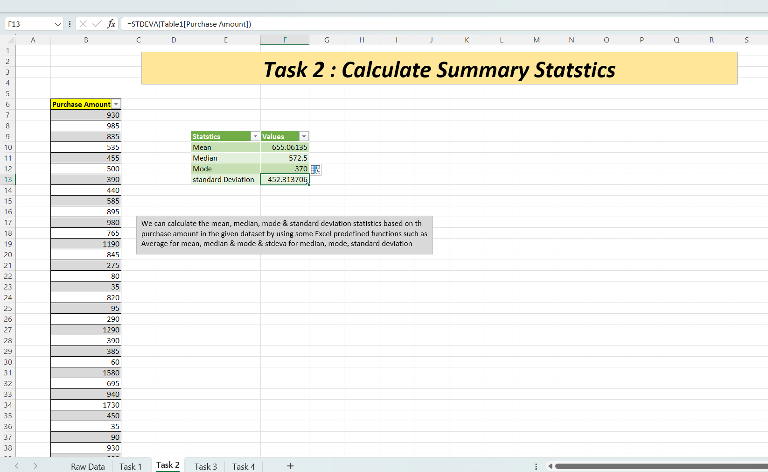

**Project Title:** Visualizing using Histogram

* **Topic:** Created a histogram or bar chart to visualize the distribution of data in a dataset
* **Technologies Used:** Excel
* **Team Members Name (Individual):** Dinesh Kumar
* **Screenshot of Result and Code:**

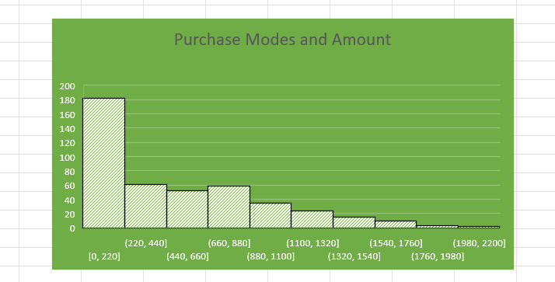

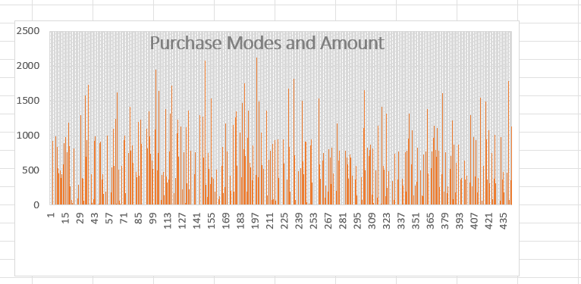

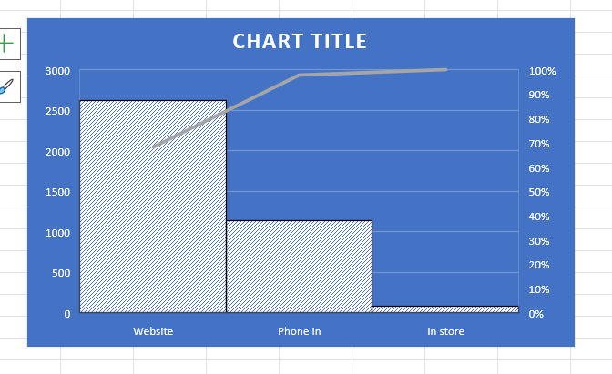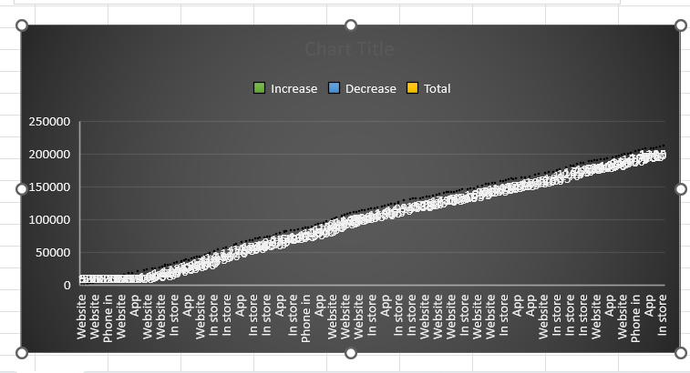

**Project Title:**  Pivot Table

* **Topic:** Used pivot tables to summarize data in a dataset
* **Technologies Used:** Excel
* **Team Members Name (Individual):** Dinesh Kumar
* **Screenshot of Result and Code:**

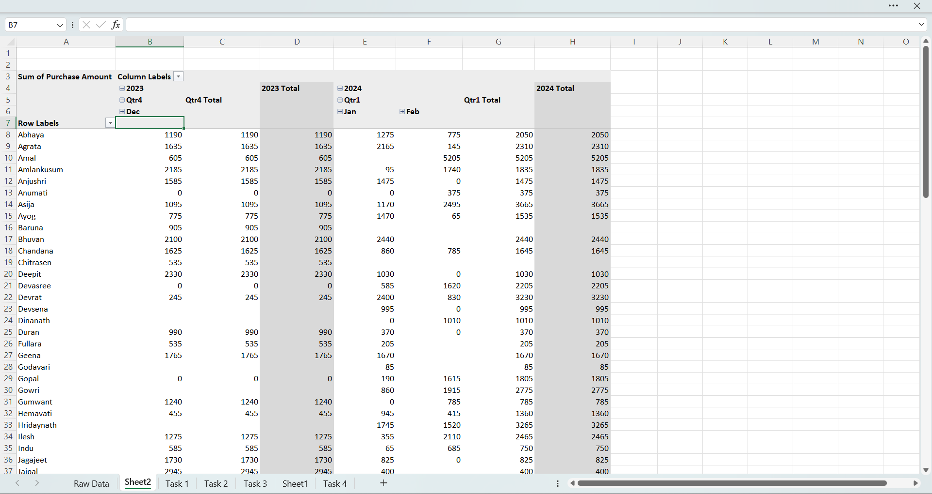

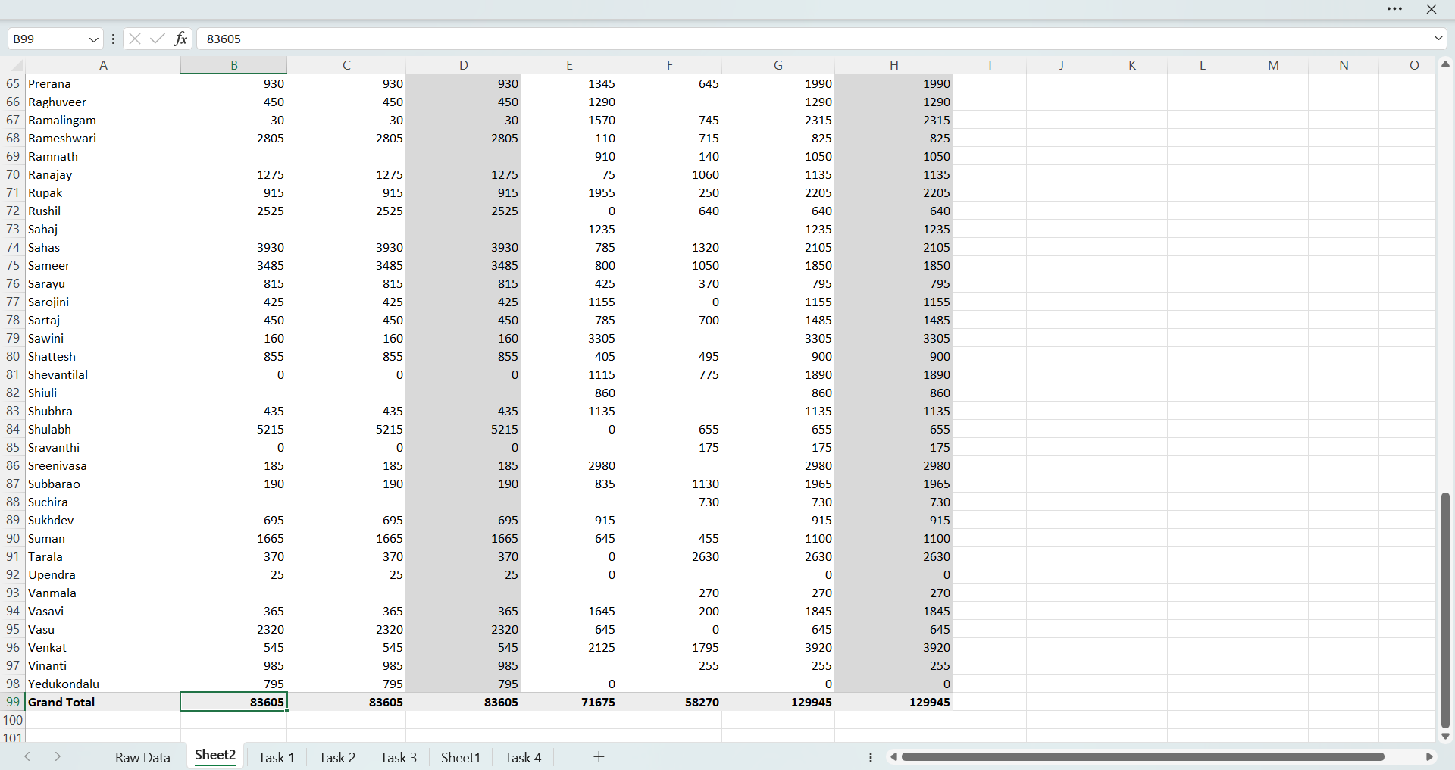

**Project Title:** Dashboard using power bi

* **Topic:** Created a dashboard to display insights and visualization from a dataset
* **Technologies Used:** Power BI
* **Team Members Name (Individual):** Dinesh Kumar Manimela
* **Screenshot of Result and Code:**

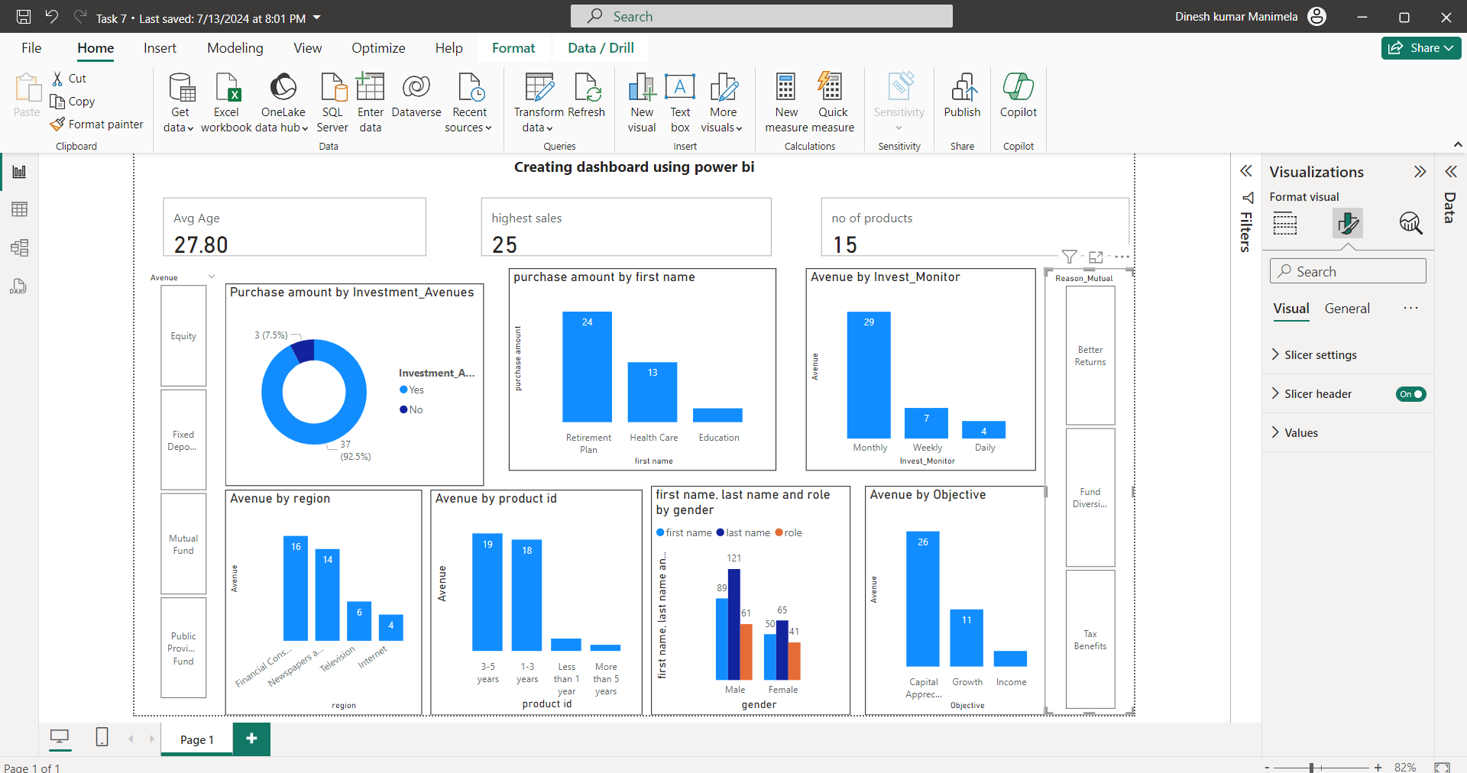

**Conclusion**

In conclusion, my 4-week internship with TechnoHacks EduTech Company has been immensely valuable, enriching my understanding and expertise in data analytics. Collaborating closely under the mentorship of Mr. Sandip Gavit, I have refined my practical skills, actively engaged in hands-on projects, and mastered the deployment and execution processes for data analytics models.

Throughout this internship, I have adeptly applied theoretical concepts to tackle real-world data challenges in analytics, ensuring that the solutions I developed meet industry standards and follow best practices. The immersive experience and exposure to various aspects of data analytics have significantly bolstered my grasp of this field, establishing a strong foundation for my future endeavors in analytics and data-driven decision-making.

I extend my sincere gratitude to TechnoHacks EduTech Company and Mr. Sandip Gavit for offering me this invaluable opportunity. I am excited to apply the knowledge and skills acquired here in my upcoming journey as a data analytics practitioner, contributing to the evolution of data analytics technologies and enhancing data-driven decision-making processes.

**Declaration**

I, Dinesh Kumar Manimela, hereby declare that the Data Analytics Internship Report of 4 weeks, presented herein, is a culmination of my participation in the Data Analytics Internship Program offered by TechnoHacks EduTech, under the esteemed guidance of Mr. Sandip Gavit.

I affirm that all the work presented in this report, including but not limited to project development, documentation, and analysis, has been carried out solely by me. Furthermore, I declare that all the details provided in this report are accurate to the best of my knowledge and belief.

I acknowledge that this internship report has been reviewed and approved by Mr. Sandip Gavit, my industry supervisor, whose guidance and mentorship have been instrumental in my learning and growth during the internship period.

I understand that any attempt to misrepresent or falsify the information presented in this report is a breach of academic integrity and professional ethics, and I take full responsibility for the content provided herein.

Date: 07/07/2024

Signature:





Industry Supervisor's Signature:

**Reference**

1. **Kaggle:** Known for its datasets, competitions, and tutorials, Kaggle is a valuable resource for learning data science and machine learning techniques through hands-on projects.
2. **Data Camp:** Offers interactive courses and tutorials on data analysis, and data visualization using excel, power bi, and SQL, making it a popular choice for learning data analytics skills.
3. **Towards Data Science (Medium publication):** This publication features a wide range of articles, tutorials, and case studies on data science, machine learning, and data analytics, providing insights from industry experts and practitioners.
4. 4.**Coursera:** Provides online courses and specializations in data analytics, data science, and related fields from universities and institutions worldwide, offering a structured learning path with certificates upon completion.